Mini Project – GradeBook Analyzer
Course: Programming for Problem Solving using Python
Name: Daksh Gautam
Course title: BTECH CSE AI &ML
Section- “C”
Submission Date: 25 Nov 2025

Real-World Problem (In My Words)
Teachers usually spend a lot of time checking student marks, calculating averages, finding toppers, and giving grades. Doing this manually takes effort, so I made a simple Python program called GradeBook Analyzer.
This program takes student names and marks (either typed manually or from a CSV file) and then automatically calculates statistics, assigns grades, and shows everything in a clean table.

Learning Outcomes (What I Learned)
While making this project, I learned how to:
- Take input manually or read data from a CSV file.
- Store data in lists and dictionaries.
- Calculate average, median, minimum, and maximum marks.
- Use loops and if–else to assign grades.
- Use list comprehension for pass/fail.
- Display data in a proper formatted table.
- Make a simple CLI menu for repeated use.

TASKS I Completed

Task 1: Project Setup
I created a folder gradebook_analyzer and inside it I made the main Python file gradebook.py.
I added my name, date and title at the top as comments.
When the program starts, it prints a welcome message and gives two choices:
- Manual input
- CSV file input

Task 2: Entering Data / Importing CSV
Here I added two options:
a) Manual Input
I typed student names and their marks one by one.
b) CSV File Input
I used the csv module to read names and marks from a file.
All the data was stored in a dictionary like: 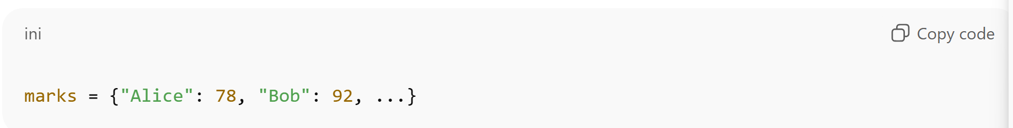

Task 3: Statistical Analysis
I created functions to calculate:
- Average marks
- Median marks
- Highest marks
- Lowest marks
These functions take the dictionary and return correct results.

Task 4: Grade Assignment
I assigned grades based on this rule:
- A: 90 and above
- B: 80–89
- C: 70–79
- D: 60–69
- F: below 60
I stored them in a new dictionary: 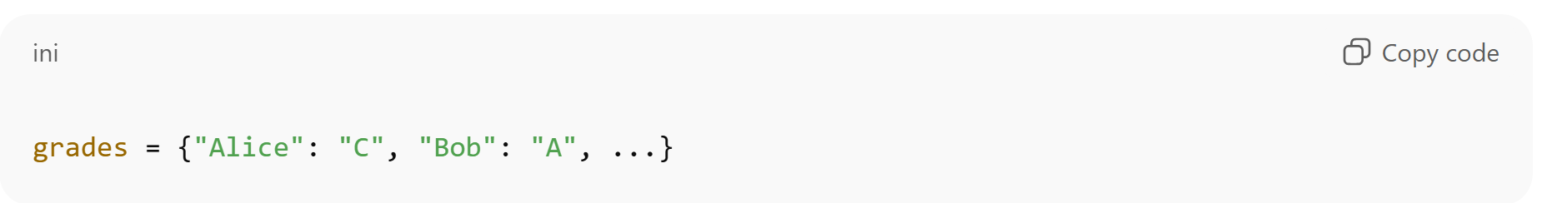
I also counted how many students got A, B, C, D, and F.

Task 5: Pass / Fail Using List Comprehension
Using list comprehension: 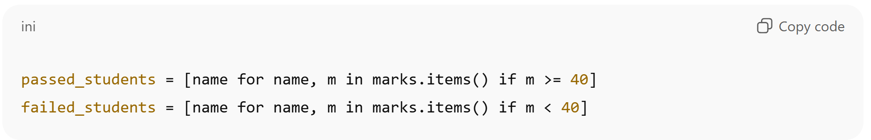
Then I printed both lists.

Task 6: Final Results Table + Program Loop
At the end, I printed the results in a clean table: 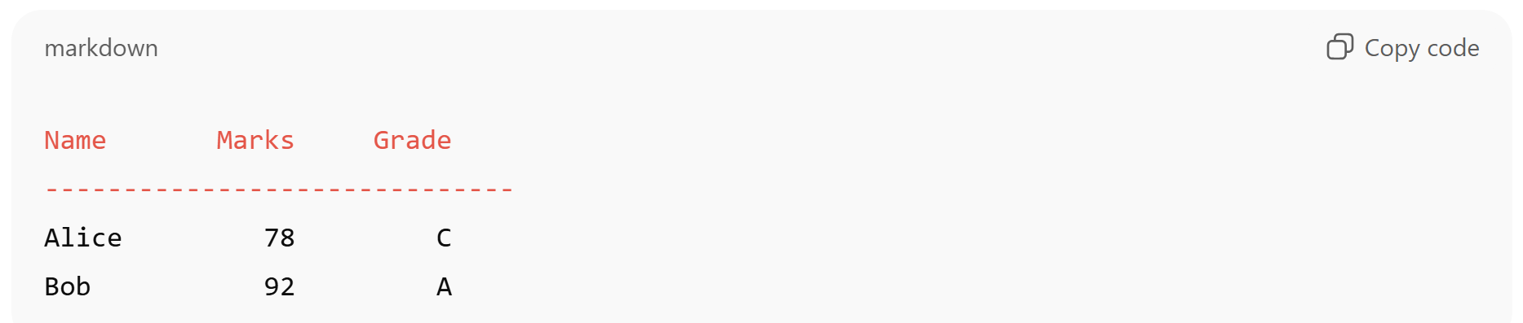
A loop lets the user run the analysis again or exit.

Submission Checklist (Done by Me)
✔ gradebook.py created
✔ Both input methods work
✔ All 6 tasks completed
✔ Tested with 5 students + 1 CSV
✔ Functions and comments added
✔ Optional CSV export (bonus – if done)

Conclusion :
This mini project helped me understand how Python can automate real-life tasks. I learned data handling, calculations, grading, file reading, and proper presentation of output. It improved my confidence in writing modular code.

